**Time Distributor v2**

Git Repo: <https://github.com/jm55DLSU/TimeDistributor>

**Project Description:**

This project was a commission for purposes of human resource management. Specifically, the task was to simply distribute a certain task (transcribing in this case) across several people by dividing the number of people on a given individual allotted time over a total allotted time.

**Example:**

1. Sample Input:
   1. Total Time (hh:mm:ss): 03:23:19
   2. Duration (hh:mm:ss): 00:03:50
   3. Names: 53 generated names (system-generated used on example output)
2. Sample Output
   1. Expected  
      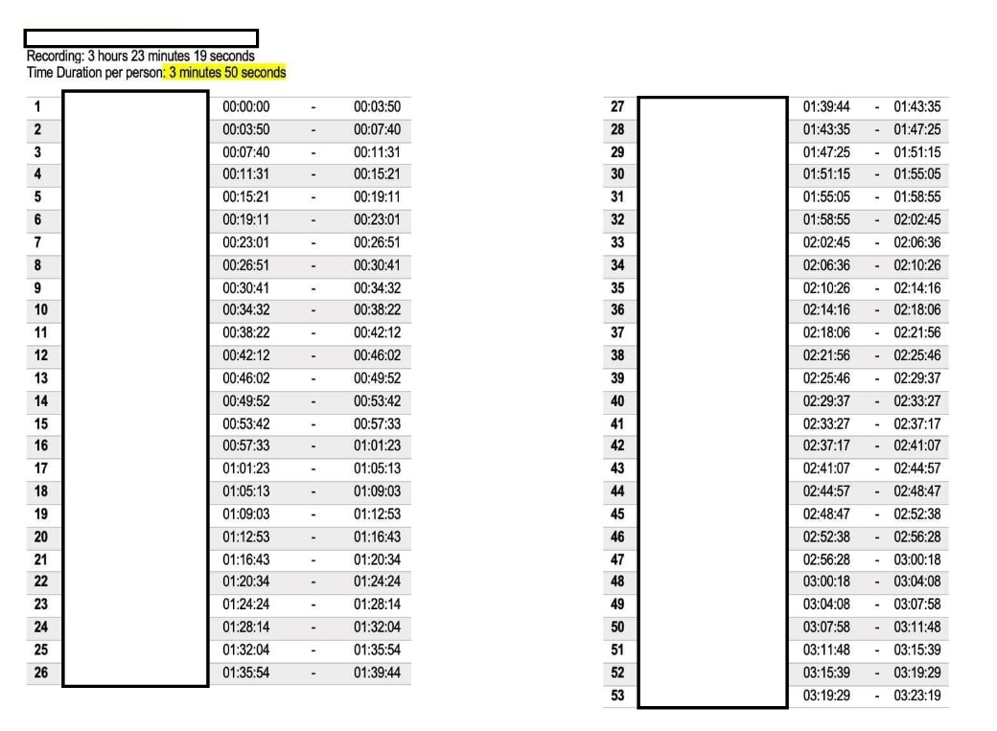
   2. Actual  
      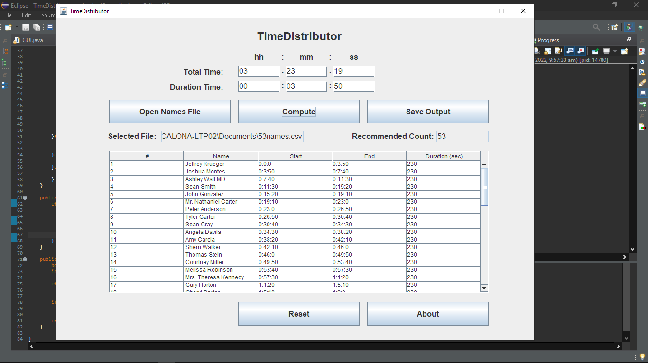

**Instructions:**

1. Create a .csv file containing the names of the people (Required)
   1. Open the existing spreadsheet file of names
   2. Copy the names on a new spreadsheet file
      1. Copy existing namesGraphical user interface, application, table, Excel

         Description automatically generated
      2. Paste to new notepad file and save normally.  
         Graphical user interface, text, application

         Description automatically generated
2. Using the program
   1. Open the program  
      Graphical user interface, application

      Description automatically generated
   2. Instructions c and d may come in any order.
   3. Click ‘Open Names File’ to select the recently saved ‘.txt names file.  
      Graphical user interface, application, Word

      Description automatically generated  
      Graphical user interface, application

      Description automatically generated  
      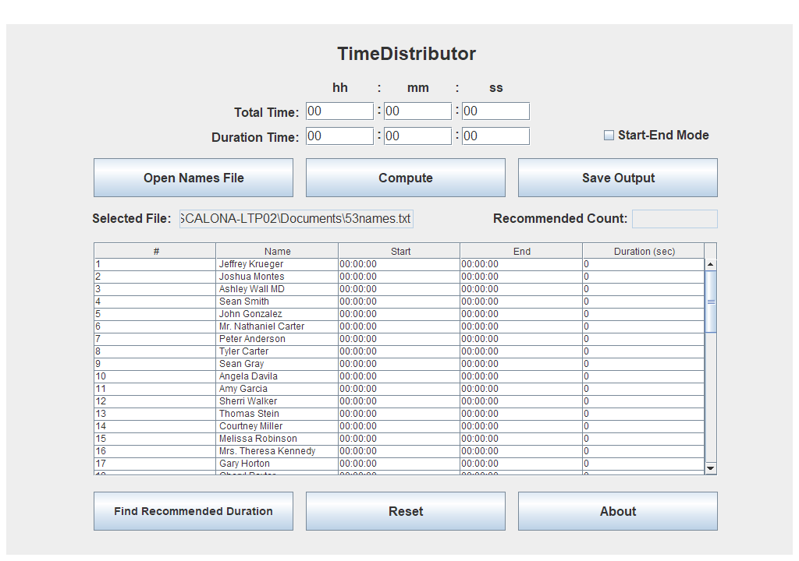
   4. Set the time configurations and click ‘Compute’  
      Graphical user interface, application, table

      Description automatically generated

* 1. Click ‘Save Output’ to save as file when needed  
     Graphical user interface, application

     Description automatically generated

1. Start-End Mode
   1. You may also make use of a start and end time instead of the total and a pre-determined time duration.
   2. Simply click the ‘Start-End Mode’ checkbox and enter the start and end times instead of the total and duration time respectively.  
      Graphical user interface, text, application, Word

      Description automatically generated
2. Open the newly saved file and it is recommended for you to save it as a ‘.xlsx’ (Excel) file.  
   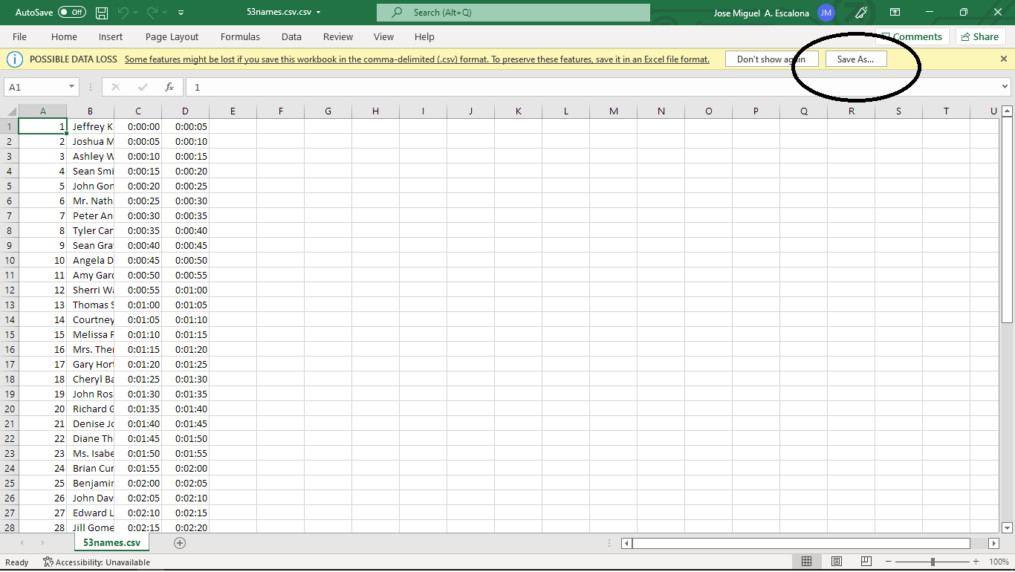  
   Graphical user interface, application

   Description automatically generated
3. Finding “Recommended Time Duration”, click “Find Recommended Duration” button and enter the required inputs. Please ensure that the time is formatted as ‘hh:mm:ss’.  
   Graphical user interface, text, application, Word

   Description automatically generated  
   Graphical user interface, application, Word

   Description automatically generated  
   Graphical user interface, Word

   Description automatically generated  
   Graphical user interface, application

   Description automatically generated